The Parabolic Reflector Microphone

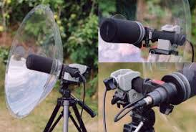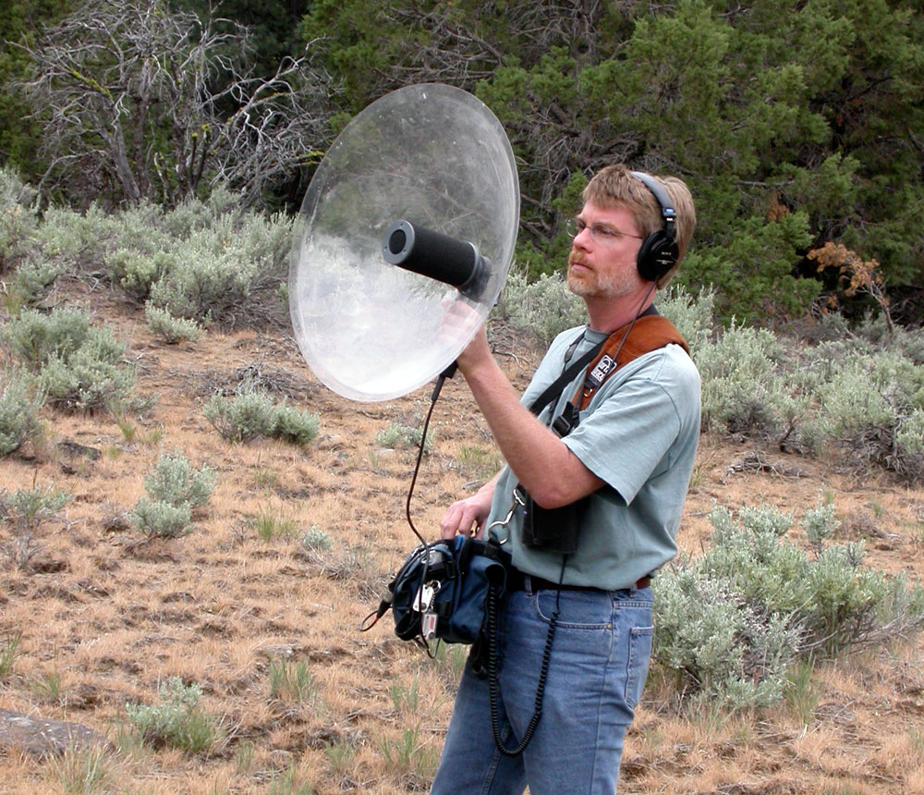

Definitions
- A parabolic microphone is an instrument that uses a parabolic reflector to collect and focus sound waves on a transducer.
- A transducer is a device that converts energy from one form to another. (In this case, it turns sound energy into electrical energy.)
Uses
- Sporting Events - Audio recording on the sideline or interviews
- Bird Calls
- Espionage - used in past wars such as WWII.
- Law Enforcement - used for scouting an area
Other Commonly Used Mics
Shotgun Mic - Used commonly for interviews. Directional mic that picks up audio between 1 and 3 feet.
Lav Mic - Used commonly for interviews. Attached onto subjects’ shirt or area near their mouth to pick up their voice.

How it Works and the Math Behind it All

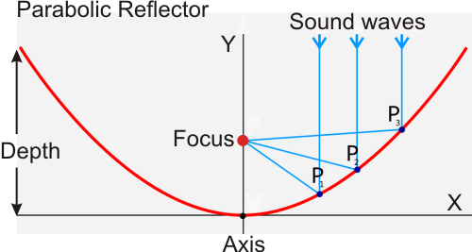
Math Definitions
- A parabola is a set of all points in a plane that are equidistant from a fixed line (directrix) and fixed point (focus) in the plane.
- Axis of the parabola - the line that goes through the focus and is perpendicular to the directrix
- Vertex of the parabola - the point of intersection of the parabola with the axis.
Important Ideas
- Anything approaching the dish that is parallel to the dish’s center line and perpendicular to the directrix is then reflected and focused to a single point (the focus
- The audio signal is reduced by 6dB when the distance is doubled.
- However, the amplifier that is on the mic is able to gather all the sound it picks up, regardless the distance, and increase the audio and noise levels.

Inverse Square Law - a law stating that a specified physical quantity or intensity changes in inverse proportion to the square of the distance from the source.
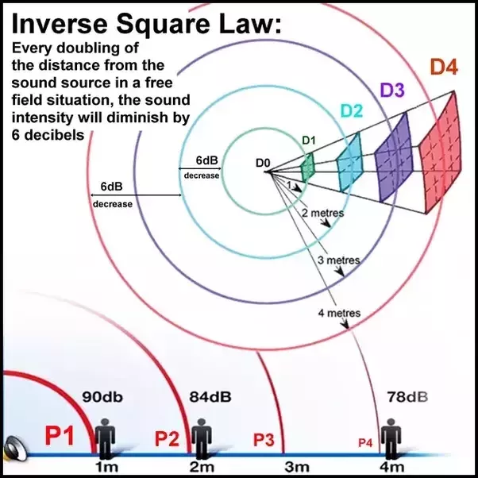

Question:
The cross section of a satellite dish is a parabola. Signals from a satellite strike the surface of the dish and are reflected to a single point (the focus), where the receiver is located. If the dish is 16 feet across at its opening and 2 feet deep at its center, at what a position should the receiver be placed? (Find p)
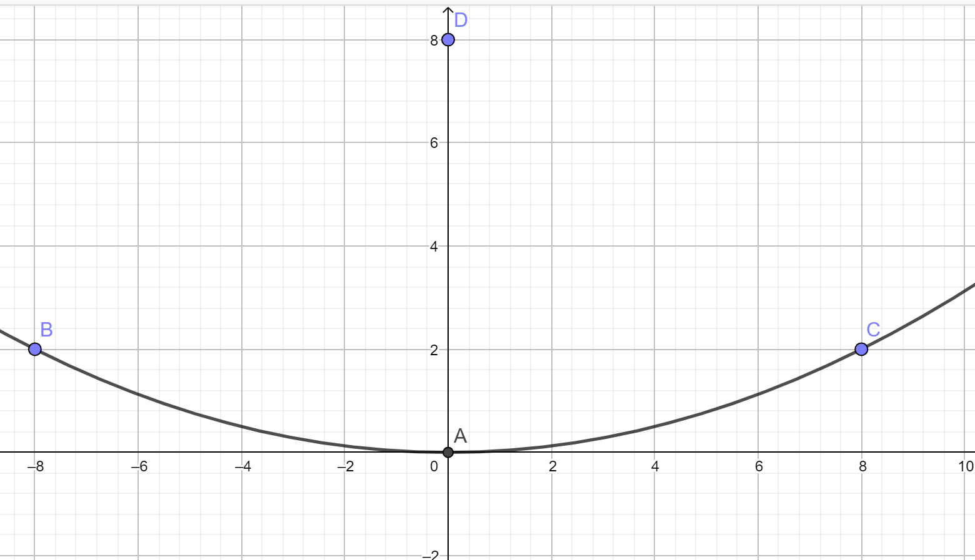
Hint: The equation for finding the focus: x² = 4py

